**NAME: MUHAMMAD OMER SIDDIQUI**

**ROLL NO: 20B-104-SE**

**SECTION: B**

**REPORT OF ANALYSIS:**

The data set that I have selected is IPL data set. I have analyze the data from start and I have only taken a reference from the kaggle’s starter code and I have analyzed the starter code. From that data I perform two analysis: one is how many matches are played in each ground. So after performing analysis, the most of the matches are played in Wankhede Stadium, Mumbai. i.e. 21.

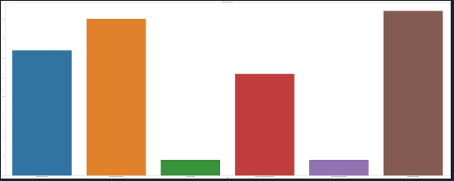

And the second one is the toss winning percentage of each team. After the analysis I get the information that Gujrat and Hyderabad both have the same percentage of winning a toss i.e. 10%.

